Pipeline -1
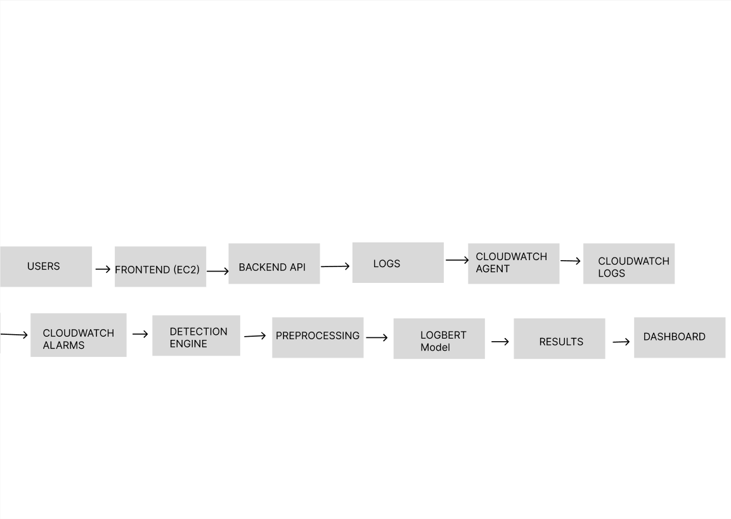
This pipeline is used to demonstrate how the system works in a real-time cloud environment. It allows the system to collect logs, monitor activity, detect anomalies, and display results instantly. This is important for cybersecurity because threats need to be identified as they occur. In this pipeline, users interact with the system through a frontend dashboard hosted on Amazon Web Services EC2. The backend API processes requests and generates application logs. These logs are collected using CloudWatch Agent and stored in CloudWatch Logs. CloudWatch Alarms monitor the logs and trigger alerts when abnormal patterns are detected. The detection engine then preprocesses the logs and applies the LogBERT model to identify anomalies. Finally, the results are sent back to the dashboard for visualization.

Pipeline 2
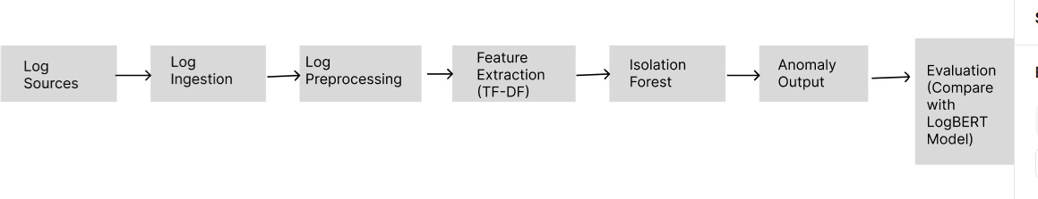
This pipeline is used to train and evaluate a baseline anomaly detection model before deployment. It helps in understanding how well the model performs on different datasets and provides a comparison with more advanced models like LogBERT. In this pipeline, log data is collected from various sources such as benchmark datasets and generated logs. The data is then ingested and preprocessed to remove noise and standardize the format. Feature extraction techniques such as TF-IDF are applied to convert text data into numerical form. The processed data is then used to train an Isolation Forest model, which detects anomalies. The output is evaluated using performance metrics such as precision, recall, and F1-score, and the results are compared with LogBERT.

Pipeline 3
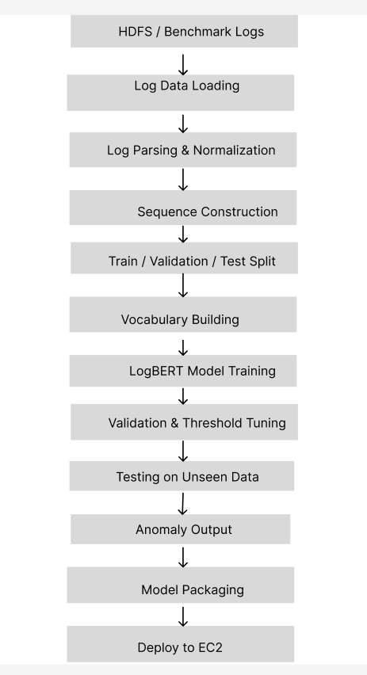
This pipeline focuses on developing a more advanced deep learning model (LogBERT) for anomaly detection. It ensures the model is properly trained, validated, and tested before being deployed into the cloud system. In this pipeline, log data from HDFS and benchmark datasets is collected and prepared. The logs are parsed, normalized, and converted into sequences. The dataset is split into training, validation, and testing sets. A vocabulary is built to map log events into tokens. The LogBERT model is then trained on normal log sequences and validated using threshold tuning. After testing on unseen data, the model is refined and packaged along with necessary files. Finally, the trained model is deployed to EC2 for real-time inference.

Dashboard (Visulization)
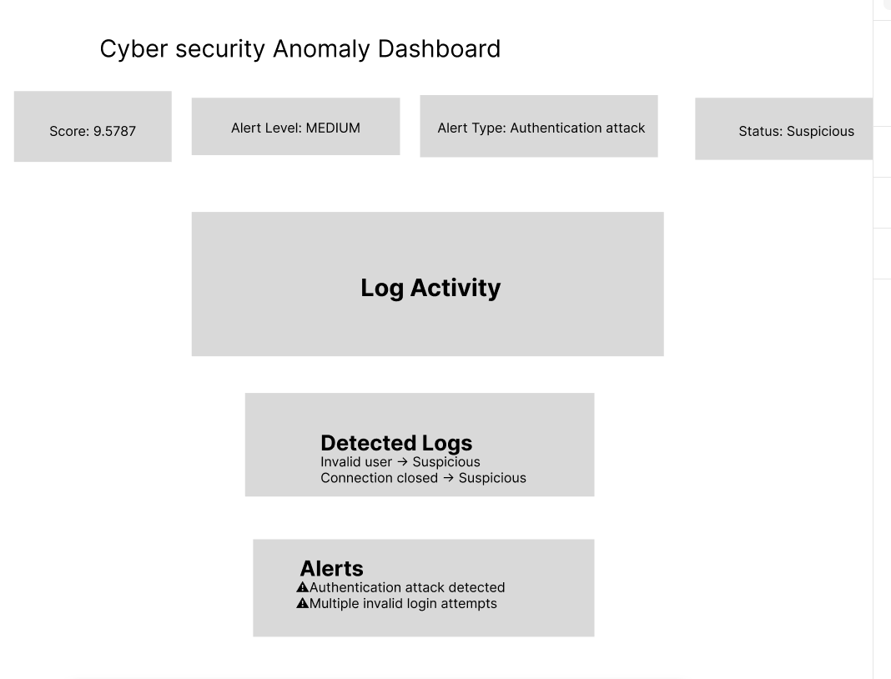
The dashboard visualizes anomaly detection results including score, alert level, detected logs, and alerts. It converts raw system output into a user-friendly interface
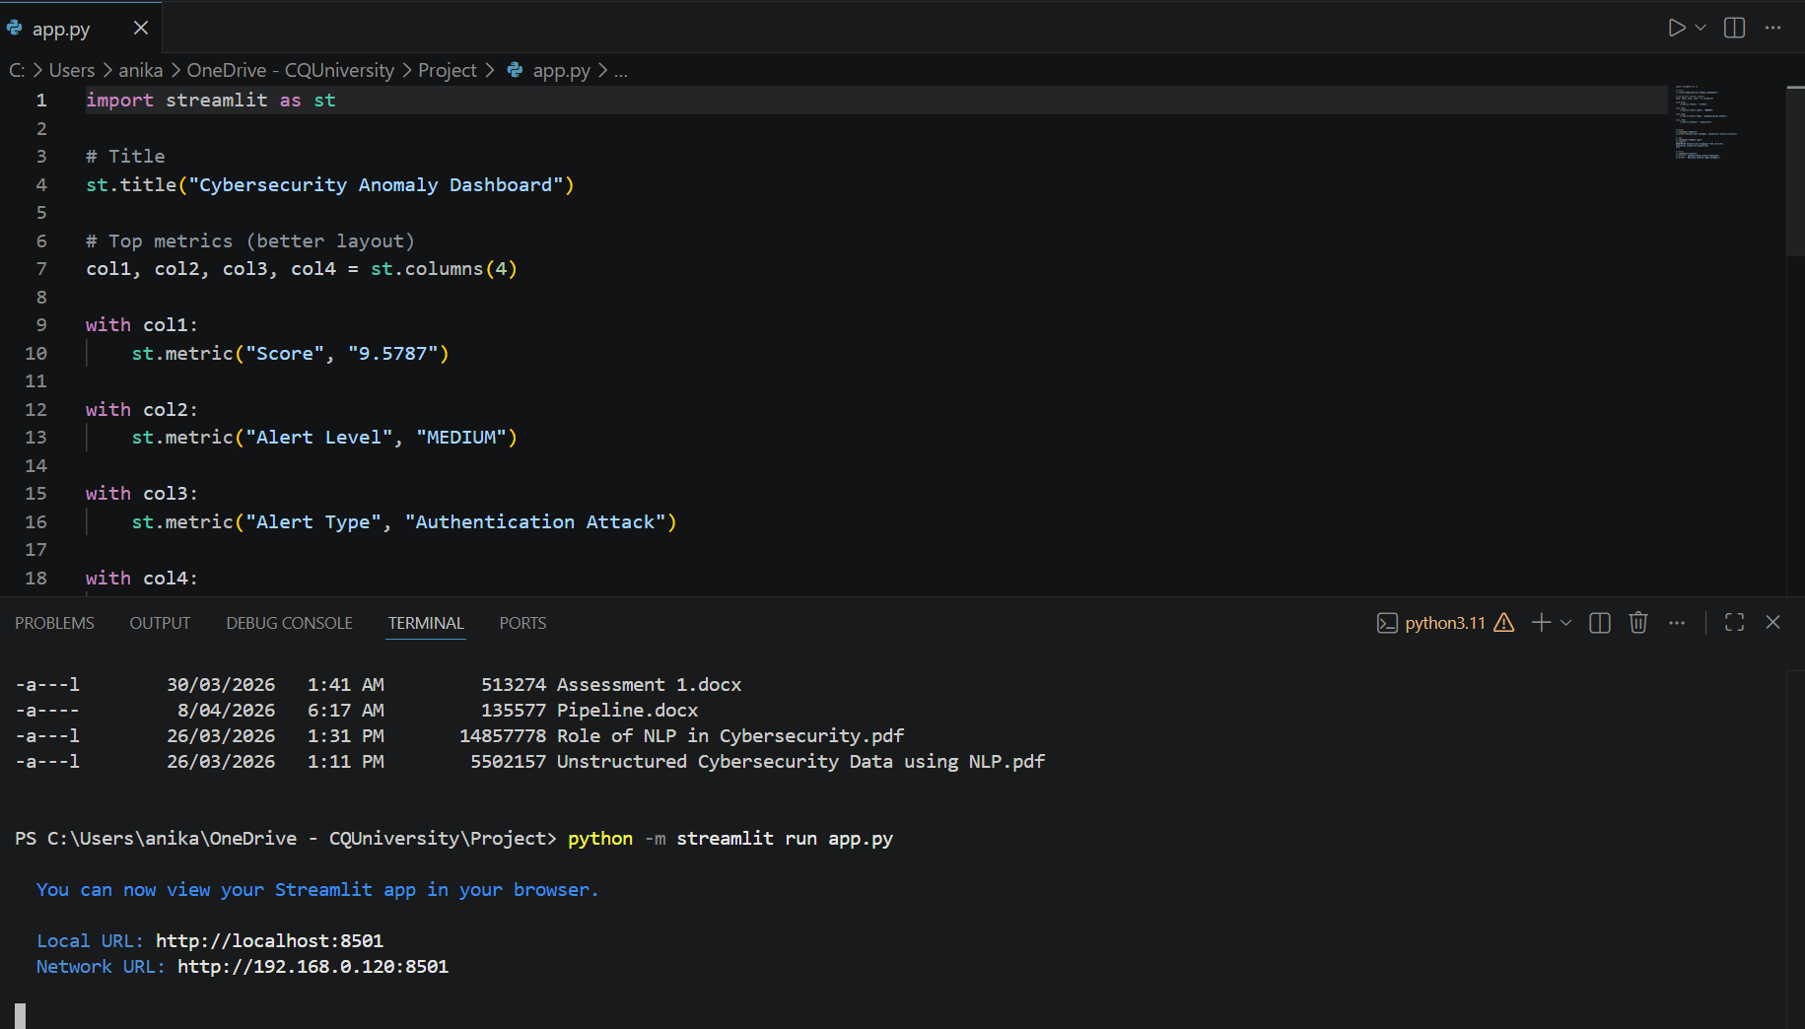

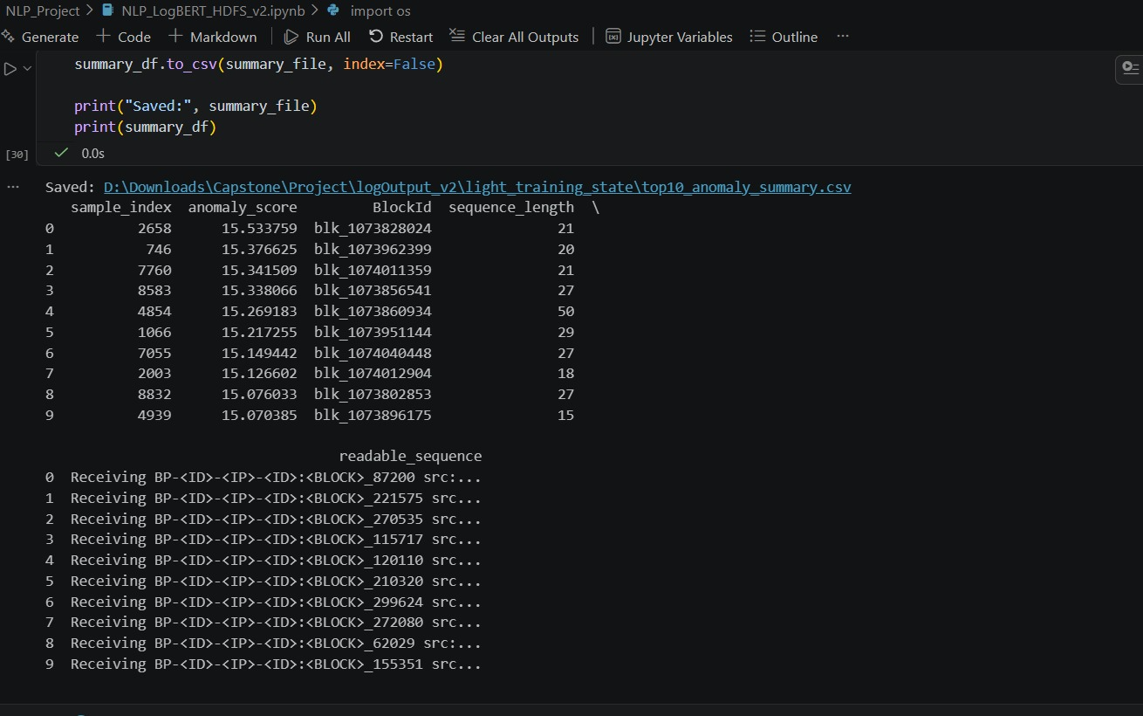
Figure 1: LogBERT anomaly detection summary output saved as CSV.
This figure shows the generated anomaly summary containing sample index, anomaly score, block ID, and sequence details. The results are stored in a CSV file (top10_anomaly_summary.csv) for further analysis and integration into the visualization layer.

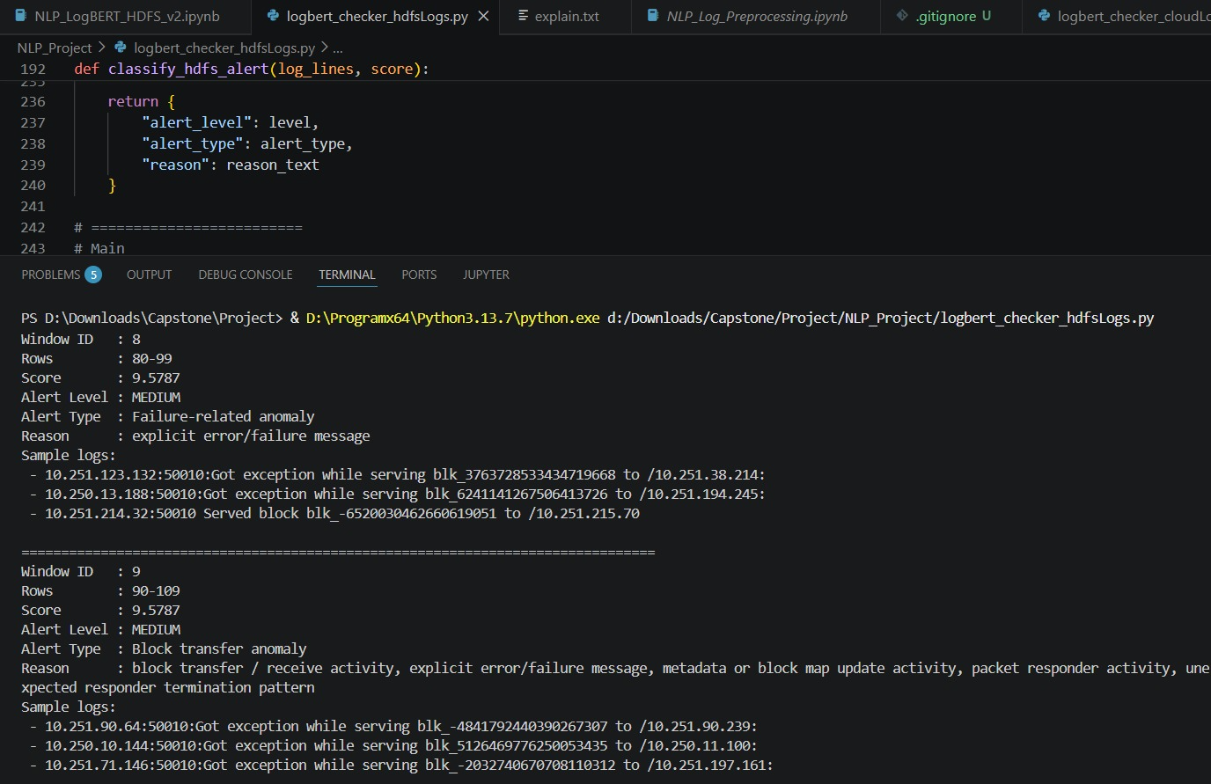
Figure 2: Anomaly detection results from HDFS logs using LogBERT.
This output displays detected anomalies including anomaly score, alert level, alert type, reason, and sample log entries. It demonstrates how the system identifies failure-related and block transfer anomalies from structured log data.

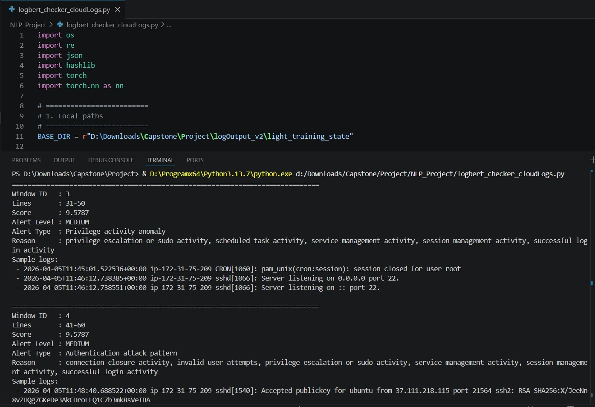
Figure 3: Anomaly detection results from cloud-based logs.
This figure presents anomalies detected from cloud system logs, including authentication attack patterns and privilege-related activities. The output includes alert levels, reasons, and sample logs, highlighting suspicious behavior in real-time environments.

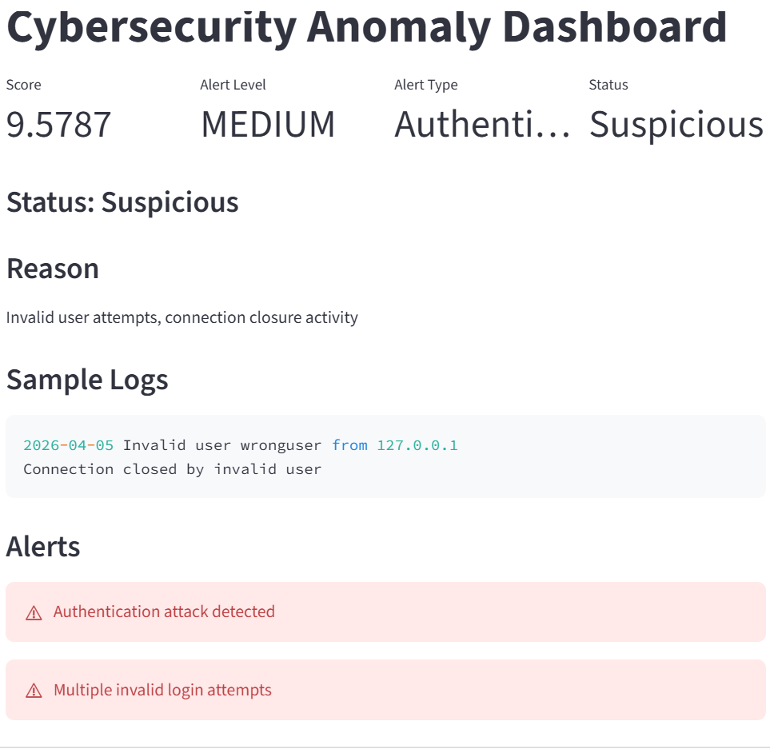
I implemented a Streamlit dashboard to visualize real anomaly detection results generated by the LogBERT model

